Ingress Context Path based routing:-
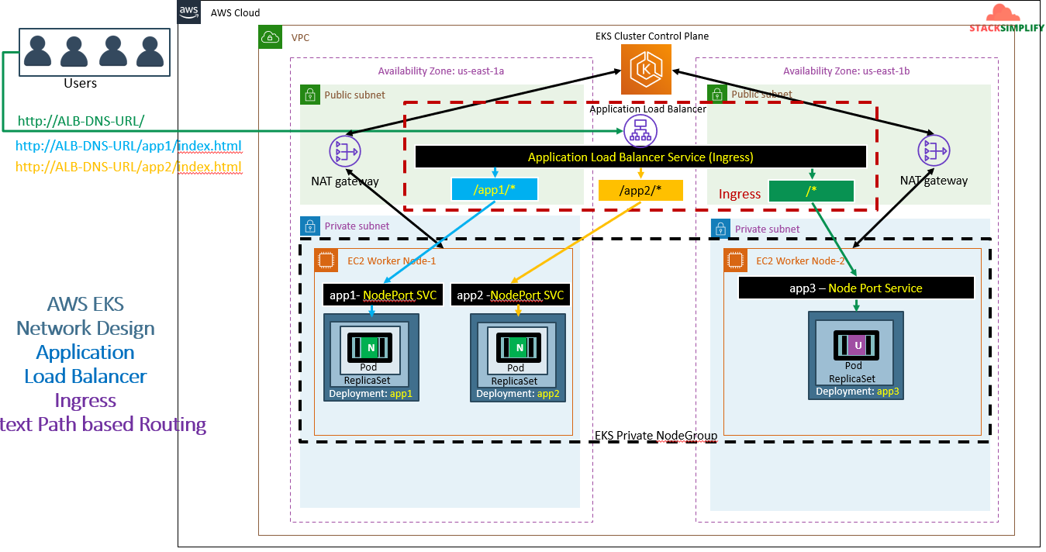
Same network Kubernetes perspective:-
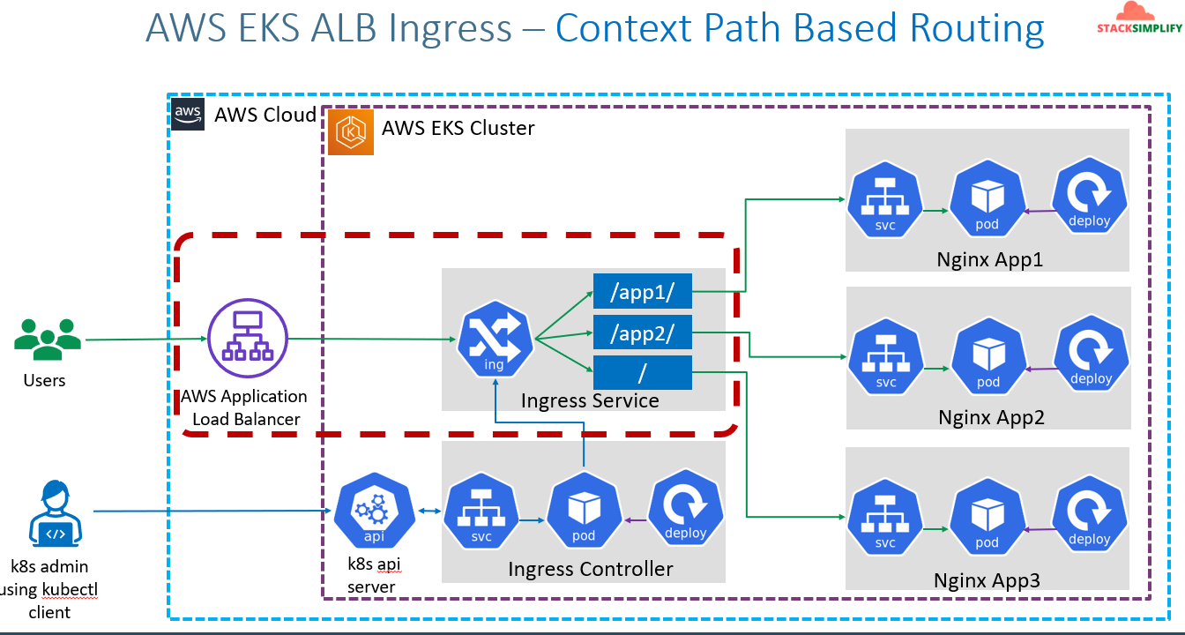
Here don’t see ALB and Ingress service don’t see it as different both are single object only.
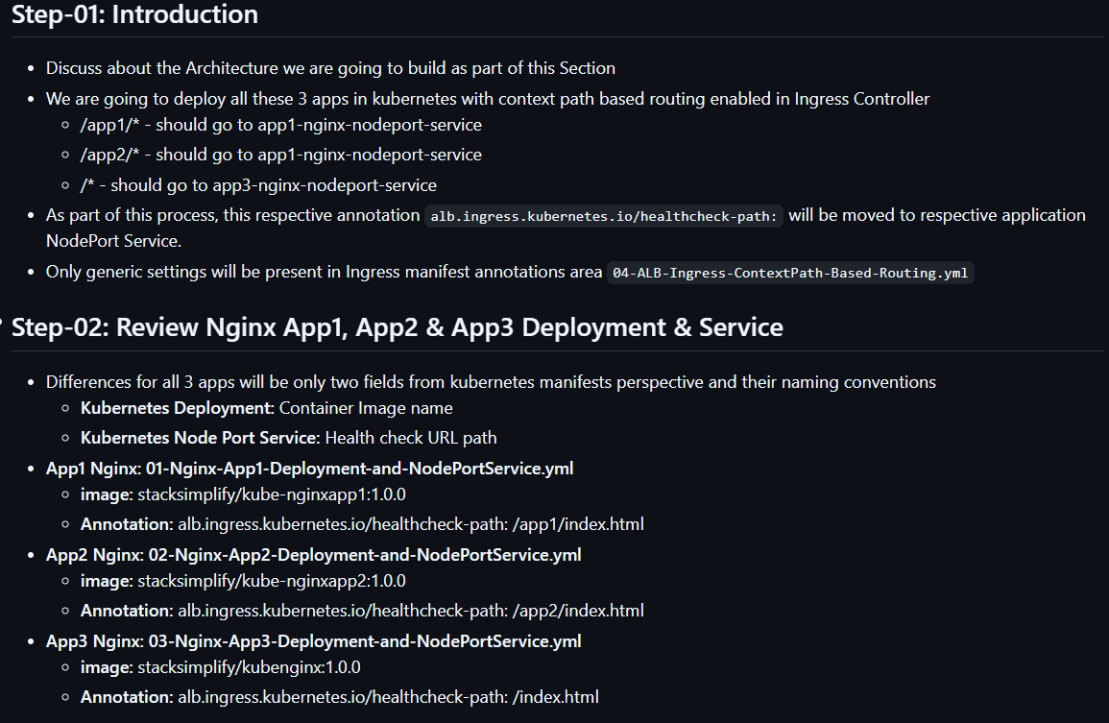
As part of context path we will mention the annotation alb.ingress.kubernetes.io/healthcheck-path: for thar respective nodeport service. It will create each port for each annotation health check path.
We have to create 3 apps with different paths. For that we need each deployment and nodeport service manifest should be separated as per the context path.
For app1 we have defined both deployment and nodeport service in single manifest.
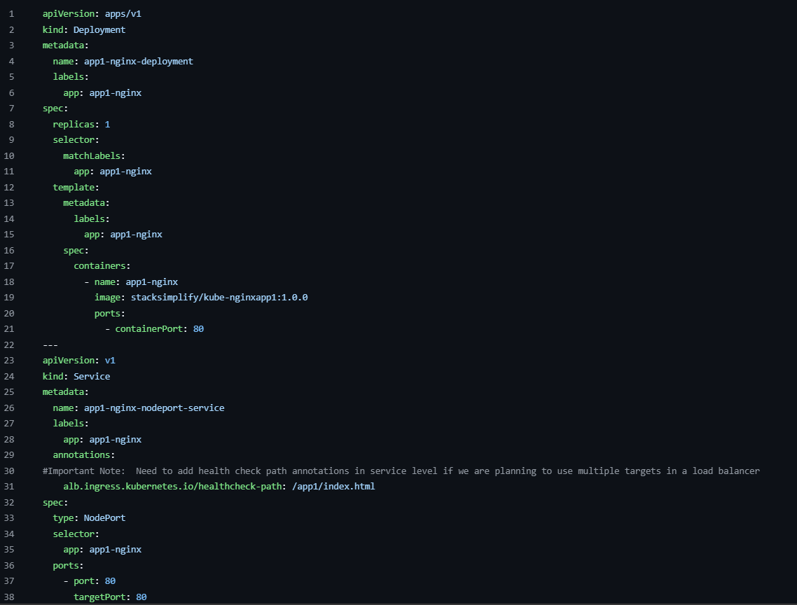
You can see the healthcheck annotation in nodeport service.
For app2:
For app3: 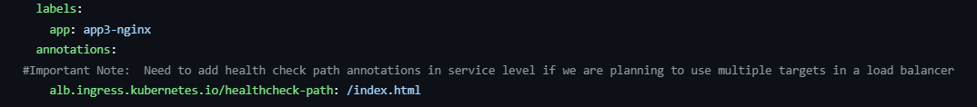
Now we are going to write ingress manifest.While writing ingress manifest at path we need to define nodeport service name for each path like below. 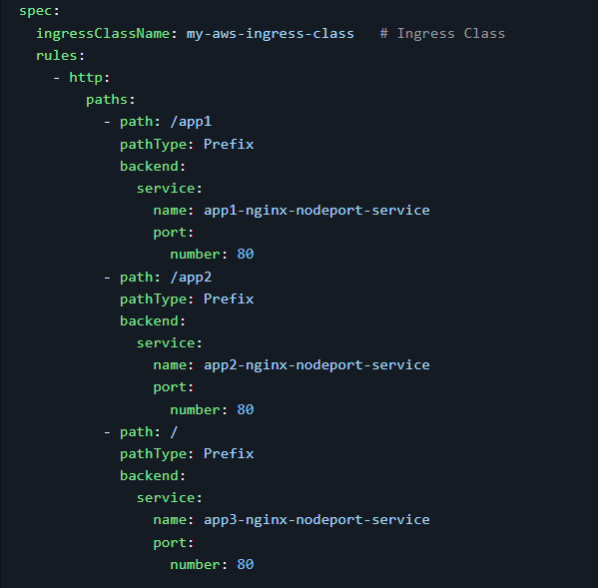
The annotations won’t change it will be the same which we have used for previous session.
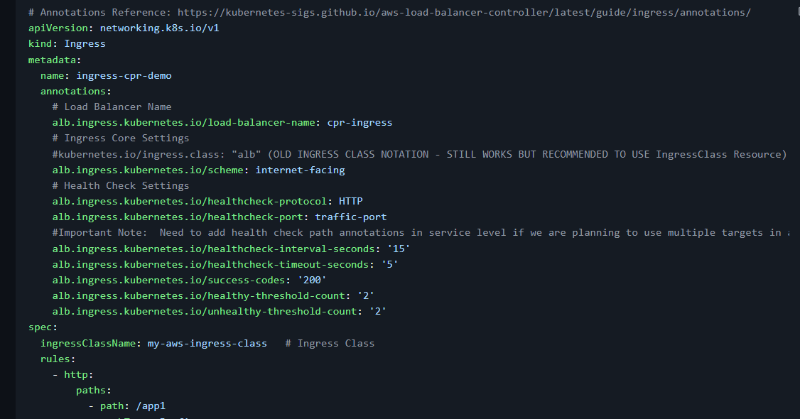
Verify
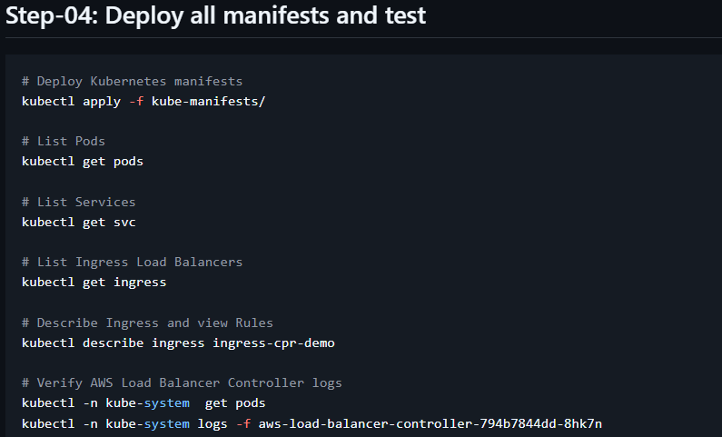
The ouputs are: 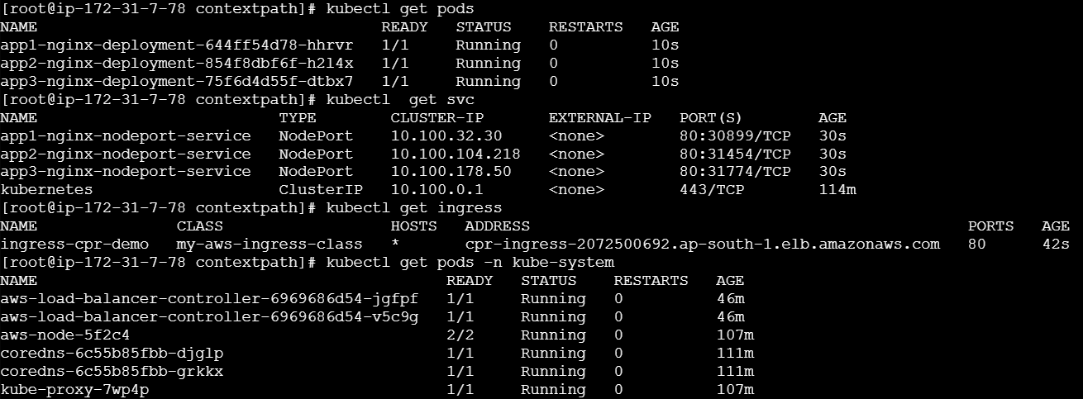
Describe of ingress service. There is no default backend.
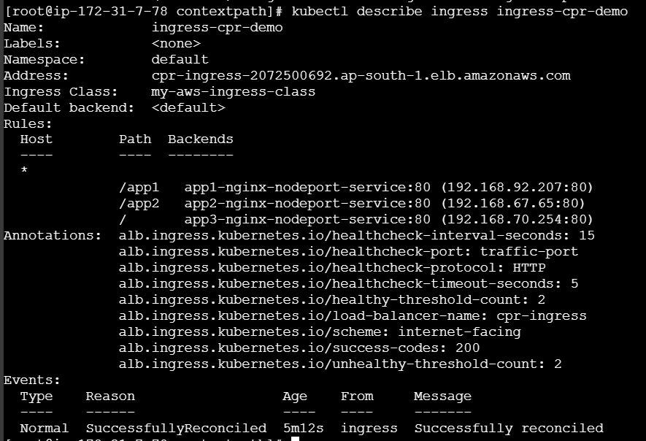
In AWS console -> ALB
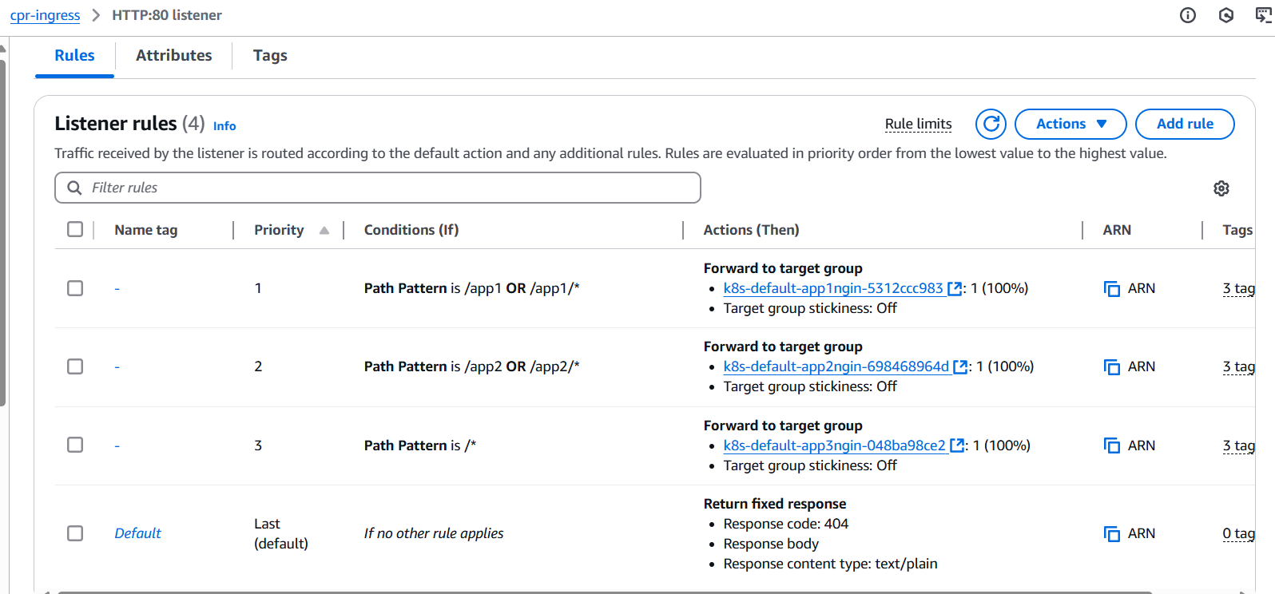
TG: 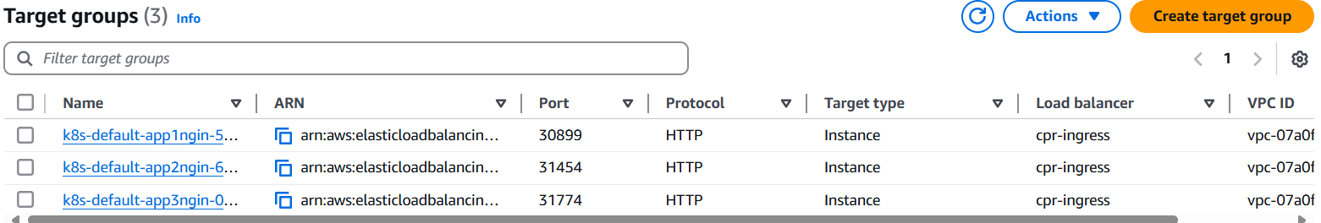
If you open any of the target group the health check path will be there. We will verify the annnotation health cheeck path in nodeport service for each target has been configured or not.
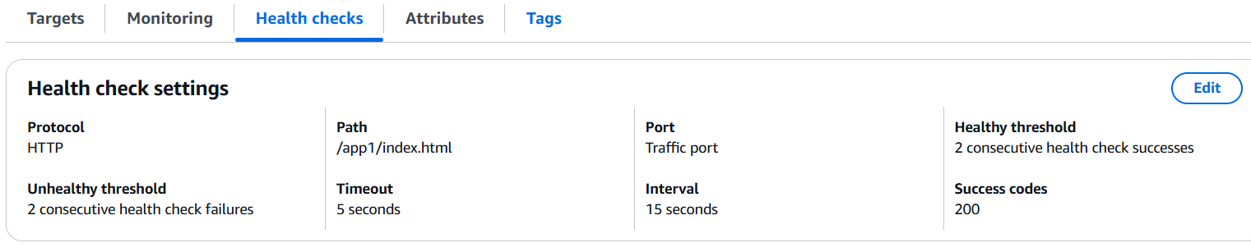
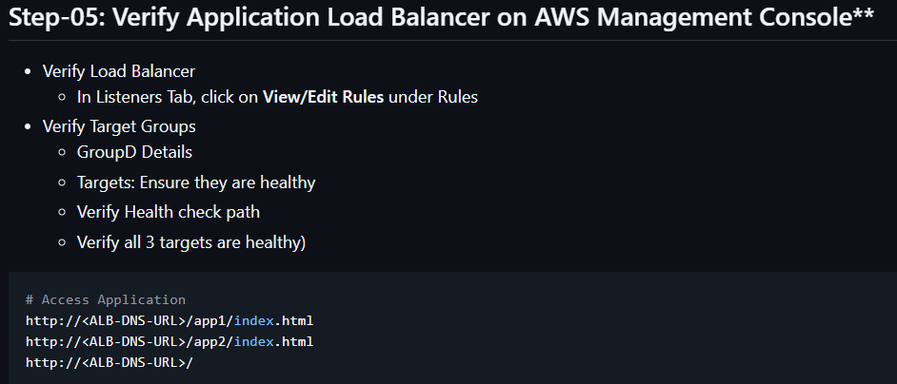
Test the order in the context path based routing:
We have configured the context path already like /app1/index.html,/app2/index.html & / .
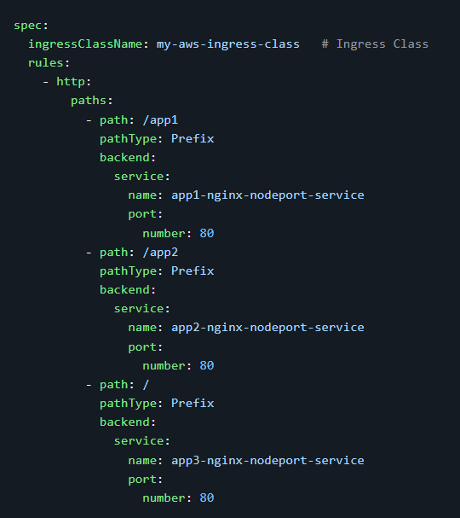
What if we change the order let’s assume ‘/’ will be at top. 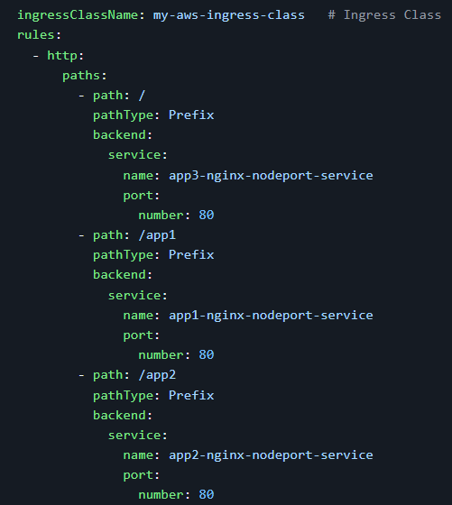
Now, if your try to access the /app1/index.html and /app2/index.html we can’t access. We can access only ‘/’. Because in listeners the path will be configured in if condition. Means if the first one satisfies it won’t go to sub context path that mean ‘/’ satisfies it won’t go to the /app1/index.html and /app2/index.html paths.
If you see the above SS it clearly defines that.
Note: Instead of /* ingress rule we can use ‘default backend’.
# Important Note-1: In path based routing order is very important, if we are going to use "/*", try to use it at the end of all rules.

# 1. If "spec.ingressClassName: my-aws-ingress-class" not specified, will reference default ingress class on this kubernetes cluster
# 2. Default Ingress class is nothing but for which ingress class we have the annotation `ingressclass.kubernetes.io/is-default-class: "true"`

